Федеральное государственное автономное образовательное учреждение высшего образования «Национальный исследовательский университет «Московский институт электронной техники»

**Лабораторная работа**

**«Задача коммивояжера, машина Тьюринга»**

Работу выполнил

Учащийся группы ПИН-33

Карпеченков Михаил Владимирович

Под руководством

Волкова Александра Сергеевича

**Москва 2022**

**Алгоритм решение методом ветвей и границ:**

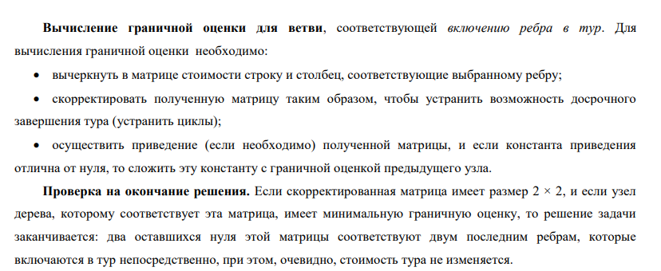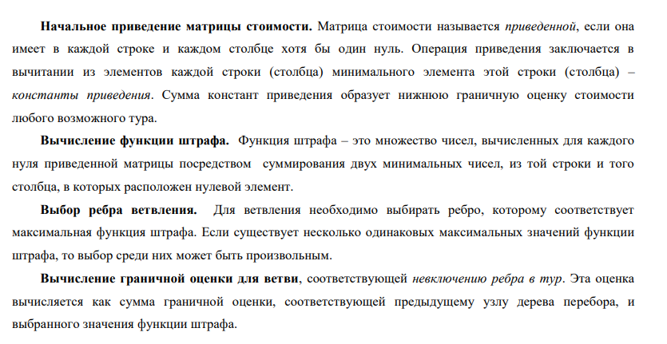

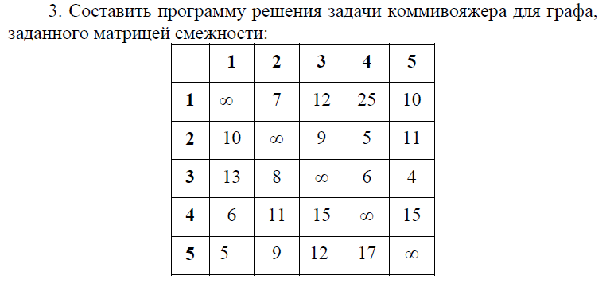

Вывод программы объемен, поэтому вставлю текстом:

STEP 1

GRAPH:

V | 1 2 3 4 5

-------------------------

1 | M 7 12 25 10

2 | 10 M 9 5 11

3 | 13 8 M 6 4

4 | 6 11 15 M 15

5 | 5 9 12 17 M

Finding and counting di:

di: [0, 5, 4, 6, 5];

V | 1 2 3 4 5 | di V | 1 2 3 4 5 | di V | 1 2 3 4 5

----------------------------- --------------------------------------- -------------------------

1 | M 7 12 25 10 | 0 1 | M 7-0 12-0 25-0 10-0 | 0 1 | M 7 12 25 10

2 | 10 M 9 5 11 | 5 => 2 | 10-5 M 9-5 5-5 11-5 | 5 => 2 | 5 M 4 0 6

3 | 13 8 M 6 4 | 4 3 | 13-4 8-4 M 6-4 4-4 | 4 3 | 9 4 M 2 0

4 | 6 11 15 M 15 | 6 4 | 6-6 11-6 15-6 M 15-6 | 6 4 | 0 5 9 M 9

5 | 5 9 12 17 M | 5 5 | 5-5 9-5 12-5 17-5 M | 5 5 | 0 4 7 12 M

On this STEP Graph:

V | 1 2 3 4 5

-------------------------

1 | M 7 12 25 10

2 | 5 M 4 0 6

3 | 9 4 M 2 0

4 | 0 5 9 M 9

5 | 0 4 7 12 M

Finding and counting dj :

dj: [0, 4, 4, 0, 0];

V | 1 2 3 4 5 V | 1 2 3 4 5 V | 1 2 3 4 5

------------------------- ----------------------------------- -------------------------

1 | M 7 12 25 10 1 | M 7-4 12-4 25-0 10-0 1 | M 3 8 25 10

2 | 5 M 4 0 6 2 | 5-0 M 4-4 0-0 6-0 2 | 5 M 0 0 6

3 | 9 4 M 2 0 => 3 | 9-0 4-4 M 2-0 0-0 => 3 | 9 0 M 2 0

4 | 0 5 9 M 9 4 | 0-0 5-4 9-4 M 9-0 4 | 0 1 5 M 9

5 | 0 4 7 12 M 5 | 0-0 4-4 7-4 12-0 M 5 | 0 0 3 12 M

------------------------- -----------------------------------

dj | 0 4 4 0 0 dj | 0 4 4 0 0

On this STEP Graph:

V | 1 2 3 4 5

-------------------------

1 | M 3 8 25 10

2 | 5 M 0 0 6

3 | 9 0 M 2 0

4 | 0 1 5 M 9

5 | 0 0 3 12 M

Finding <marks> of zeros:

V | 1 2 3 4 5

-----------------------------------

1 | M 3 8 25 10

2 | 5 M 0(3) 0(2) 6

3 | 9 0(0) M 2 0(6)

4 | 0(1) 1 5 M 9

5 | 0(0) 0(0) 3 12 M

Choosing the largest <mark>:

0(6)

Found path:

3 -> 5

[3->5]

Deleting the row and column with the highest <mark> at zero.

V | 1 2 3 4

---------------------

1 | M 3 8 25

2 | 5 M 0 0

4 | 0 1 5 M

5 | 0 0 M 12

Path at the moment:

3->5

----------------------------------------------------------------------------------------------------

STEP 2

GRAPH:

V | 1 2 3 4

---------------------

1 | M 3 8 25

2 | 5 M 0 0

4 | 0 1 5 M

5 | 0 0 M 12

Finding and counting di:

di: [0, 0, 0, 0];

V | 1 2 3 4 | di V | 1 2 3 4 | di V | 1 2 3 4

------------------------- --------------------------------- ---------------------

1 | M 3 8 25 | 0 1 | M 3-0 8-0 25-0 | 0 1 | M 3 8 25

2 | 5 M 0 0 | 0 => 2 | 5-0 M 0-0 0-0 | 0 => 2 | 5 M 0 0

4 | 0 1 5 M | 0 4 | 0-0 1-0 5-0 M | 0 4 | 0 1 5 M

5 | 0 0 M 12 | 0 5 | 0-0 0-0 M 12-0 | 0 5 | 0 0 M 12

On this STEP Graph:

V | 1 2 3 4

---------------------

1 | M 3 8 25

2 | 5 M 0 0

4 | 0 1 5 M

5 | 0 0 M 12

Finding and counting dj :

dj: [0, 0, 0, 0];

V | 1 2 3 4 V | 1 2 3 4 V | 1 2 3 4

--------------------- ----------------------------- ---------------------

1 | M 3 8 25 1 | M 3-0 8-0 25-0 1 | M 3 8 25

2 | 5 M 0 0 2 | 5-0 M 0-0 0-0 2 | 5 M 0 0

4 | 0 1 5 M => 4 | 0-0 1-0 5-0 M => 4 | 0 1 5 M

5 | 0 0 M 12 5 | 0-0 0-0 M 12-0 5 | 0 0 M 12

--------------------- -----------------------------

dj | 0 0 0 0 dj | 0 0 0 0

On this STEP Graph:

V | 1 2 3 4

---------------------

1 | M 3 8 25

2 | 5 M 0 0

4 | 0 1 5 M

5 | 0 0 M 12

Finding <marks> of zeros:

V | 1 2 3 4

---------------------------------

1 | M 3 8 25

2 | 5 M 0(5) 0(12)

4 | 0(1) 1 5 M

5 | 0(0) 0(1) M 12

Choosing the largest <mark>:

0(12)

Found path:

2 -> 4

[3->5, 2->4]

Deleting the row and column with the highest <mark> at zero.

V | 1 2 3

-----------------

1 | M 3 8

4 | 0 1 5

5 | 0 M M

Path at the moment:

3->5 -> 2->4

----------------------------------------------------------------------------------------------------

STEP 3

GRAPH:

V | 1 2 3

-----------------

1 | M 3 8

4 | 0 1 5

5 | 0 M M

Finding and counting di:

di: [0, 0, 0];

V | 1 2 3 | di V | 1 2 3 | di V | 1 2 3

--------------------- ------------------------ -----------------

1 | M 3 8 | 0 => 1 | M 3-0 8-0 | 0 => 1 | M 3 8

4 | 0 1 5 | 0 4 | 0-0 1-0 5-0 | 0 4 | 0 1 5

5 | 0 M M | 0 5 | 0-0 M M | 0 5 | 0 M M

On this STEP Graph:

V | 1 2 3

-----------------

1 | M 3 8

4 | 0 1 5

5 | 0 M M

Finding and counting dj :

dj: [0, 1, 5];

V | 1 2 3 V | 1 2 3 V | 1 2 3

----------------- -------------------- -----------------

1 | M 3 8 1 | M 3-1 8-5 1 | M 2 3

4 | 0 1 5 => 4 | 0-0 1-1 5-5 => 4 | 0 0 0

5 | 0 M M 5 | 0-0 M M 5 | 0 M M

----------------- --------------------

dj | 0 1 5 dj | 0 1 5

On this STEP Graph:

V | 1 2 3

-----------------

1 | M 2 3

4 | 0 0 0

5 | 0 M M

Finding <marks> of zeros:

V | 1 2 3

--------------------------------------------------

1 | M 2 3

4 | 0(0) 0(2) 0(3)

5 | 0(2147483647) M M

Choosing the largest <mark>:

0(2147483647)

Found path:

5 -> 1

[3->5, 2->4, 5->1]

Deleting the row and column with the highest <mark> at zero.

V | 2 3

-------------

1 | 2 M

4 | 0 0

Path at the moment:

3->5 -> 2->4 -> 5->1

----------------------------------------------------------------------------------------------------

STEP 4

GRAPH:

V | 2 3

-------------

1 | 2 M

4 | 0 0

Finding and counting di:

di: [2, 0];

V | 2 3 | di V | 2 3 | di V | 2 3

----------------- ------------------- -------------

1 | 2 M | 2 => 1 | 2-2 M | 2 => 1 | 0 M

4 | 0 0 | 0 4 | 0-0 0-0 | 0 4 | 0 0

On this STEP Graph:

V | 2 3

-------------

1 | 0 M

4 | 0 0

Finding and counting dj :

dj: [0, 0];

V | 2 3 V | 2 3 V | 2 3

------------- --------------- -------------

1 | 0 M 1 | 0-0 M 1 | 0 M

4 | 0 0 => 4 | 0-0 0-0 => 4 | 0 0

------------- ---------------

dj | 0 0 dj | 0 0

On this STEP Graph:

V | 2 3

-------------

1 | 0 M

4 | 0 0

Finding <marks> of zeros:

V | 2 3

-----------------------------------

1 | 0(2147483647) M

4 | 0(0) 0(2147483647)

Choosing the largest <mark>:

0(2147483647)

Found path:

1 -> 2

[3->5, 2->4, 5->1, 1->2]

Deleting the row and column with the highest <mark> at zero.

V | 3

---------

4 | 0

Path at the moment:

3->5 -> 2->4 -> 5->1 -> 1->2

----------------------------------------------------------------------------------------------------

STEP 5

GRAPH:

V | 3

---------

4 | 0

Finding and counting di:

di: [0];

V | 3 | di V | 3 | di V | 3

------------- => -------------- => ---------

4 | 0 | 0 4 | 0-0 | 0 4 | 0

On this STEP Graph:

V | 3

---------

4 | 0

Finding and counting dj :

dj: [0];

V | 3 V | 3 V | 3

--------- ---------- ---------

4 | 0 => 4 | 0-0 => 4 | 0

--------- ----------

dj | 0 dj | 0

On this STEP Graph:

V | 3

---------

4 | 0

Finding <marks> of zeros:

V | 3

------------

4 | 0(-2)

Choosing the largest <mark>:

0(-2)

Found path:

4 -> 3

[3->5, 2->4, 5->1, 1->2, 4->3]

Sum of Path: 36

Process finished with exit code 0